Featuring
Cody Brewer
2 X NCAA All-American
and 4 X State Champion

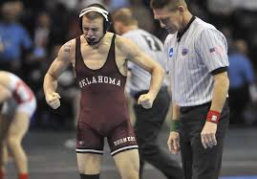

June 16-19, 2014

Coppell High School
185 West Parkway
Coppell, Texas 75019

